GRINDING PARAMETERS AND THEIR EFFECTS ON THE QUALITY OF CORN FOR FEED PROCESSING
Dabbour, M., Bahnasawy, A., Ali, S and Z. El- Haddad
Agric. Eng. Dept., Faculty of Agric., Benha Univ., Egypt.
E-mail: adel.bahnasawy@fagr.bu.edu.eg
ABSTRACT
The experiments of this study were carried out to optimize some grinding parameters and their effects on the quality of corn for feed processing. The hammer mill was evaluated under different parameters including grain moisture content and sieve hole diameter. Grinding process was evaluated by studying the performance, energy consumption, grinding index, grinding ability index, ground quality at different operation conditions. The results revealed that the mill performance, specific energy, energy density, grinding index and grinding ability index ranged from 0.70- 6.83 Mg/h, 3.38- 32.72 kJ/kg, 1.99- 18.82 MJ/m³, 12.35- 91.28 kJ.mm^{0.5}/kg and 0.81- 6.00 kJ/m², respectively. Mean weight diameter, size reduction, bulk density and grinding effectiveness ranged from 1.47- 2.89 mm, 2.60- 5.10 times, 524.58- 621.34 kg/m³ and 8.88- 14.40, respectively at different sieve hole diameter and grain moisture content.
Keywords: grinding, energy consumption, performance, fineness degree, size redction.
INTRODUCTION

Grinding is one of the most important and energy-consuming processes in cereal industry. This process consumes from 70% of total power during the feed production up to 90% during wheat flour milling. The grinding energy requirements depend on kinematical and geometrical parameters of the grinding machine and physical properties of the ground material. Knowledge of the grinding properties of grain is essential to adjust the correct parameters of grinding and sieving machines. It is the best way to produce higher and better-quality product yields at minimum energy requirements. From among the physical properties, the mechanical ones have the greatest influence on grinding energy consumption. These properties depend mainly on a cultivar, but also form agroclimatic and agro-technical factors. Wetting or drying the grains can also modify them [Glenn and Johnston, 1992; Mabille et al., 2001; Gehle, 1965; Kilborn et al., 1982; Fang, 1995 and Pujol et al., 2000].
Hassan (1994) found that increasing the screen size of hammer mill from 3.2 to 4.8 and 6.33 mm gave a decrease of 30 and 55% in grinding energy under operating conditions at drum speed 2930 rpm, no. of hammers 12 hammer and moisture content 5.1%. Increasing of drum speed from 1460 to 2930 and 3910 rpm gave a decrease of 59.1 and 67.9% in grinding energy under operating conditions at screen size of 6.35mm, no. of hammers 12 hammers and grain moisture content 5.4%. Increase of the grain moisture content from 5.4 to 8.1 and 11.4% gave an increase of 20.1 and 49% in grinding energy under operating conditions at drum speed 2930 rpm, screen size 6.35mm, no. of hammers 12 hammers. Increasing of no. of hammers from 6 to 8, 10 and 12 hammers gave a decrease of 22.8, 39.5 and 50.4 % in grinding energy under operating conditions at drum speed 2930 rpm, screen size 6.35mm and grain moisture content 5.1%. And he added that higher fineness of grinding % (fine) was obtained at lower grain moisture content and higher drum speed. In addition, as to fineness degree of grinding (medium and coarse) an opposite trend results comparing with the fineness degree of grinding (fine).
Vigneault et al. (1992) compared the specific energy, grinding rate, and particle size using a hammer mill with two hammer thickness scenarios: 3.2 and 6.4 mm. The average specific energy for thin hammer tests was 10.2 kW h/Mg, which was 13.6% less than that of the thick hammer (11.8 kW h/Mg). The grinding rate was higher for the thin hammer configuration. Dziki (2008) reported that the specific grinding energy of uncrushed kernels ranged from 72.3 to 146.7 kJ·kg⁻¹ and from 67.0 to 114.4 kJ·kg⁻¹ for Turnia and Slade, respectively. The crushing caused a decrease of specific grinding energy in both cultivars. The total specific grinding energy of crushed kernels (the sum of crushing energy and grinding energy) ranged from 47.6 to 100.5 kJ·kg⁻¹ and from 44.6 to 85.3 kJ·kg⁻¹ for hard and soft wheat, respectively. In addition, the other grinding energy indices confirmed that crushing of kernels prior to hammer mill grinding considerably reduced the grinding energy requirements. Kilborn et al. (1982) found that the total specific milling energy ranged from 46 kJ·kg⁻¹ for soft wheat cultivars to 124 kJ·kg⁻¹ for durum wheat.
Dziki and Laskowski (2006) presented the results concerning the influence of grain mechanical properties on wheat grinding energy requirements. The investigations were carried out on 10 wheat varieties (grain moisture was 15%). The results showed that the specific grinding energy ranged from 22 to 37 kJ.kg⁻¹. The grinding efficiency index ranged from 0.215 to 0.342 m².kg⁻¹. Mani et al. (2004) reported that wheat and barley straws, corn stover and switchgrass at two moisture contents were ground using a hammer mill with three different screen sizes (3.2, 1.6 and 0.8 mm). Energy required for grinding these materials was measured. Among the four materials, switchgrass had the highest specific energy consumption (27.6 kW h t⁻¹), and corn stover had the least specific energy consumption (11.0 kW h t⁻¹) at 3.2 mm screen size. Egela et al. (2003) studied the effect of the operational parameters on the fineness of the ground corn. The screen opening size was the most significant factor effect on the ground corn fineness. The screen opening size of 14 mm, number of hammers of 45 and the speed of 28.6 m/s resulted in medium ground corn fineness.
The main aim of this study is to investigate the effect of grinding parameters on the performance, energy consumption and ground quality.
MATERIALS AND METHODS
The main experiment was carried out at the Feed Manufacturing Plant, Faculty of Agriculture, Moshtohor, Benha University, during the period of 2012-2013 to optimize some grinding parameters and their effects on the quality of corn for feed processing.
1. Materials:
- Corn Grain:
Experiments were carried out on yellow corn grain different moisture contents.
-Hammer mill prototype:
Figure 1 shows the schematic diagram of the hammer mill which consists of hammer tip, rotor, hammers and screen. The hammer tip diameter is 47 cm and the mill width is 70 cm. The rotor carries four rows of rectangular hammers with a width of 4.3 cm and a length of 15 cm. The hammers swing about their pivots while the rotor is rotating. The specification of the hammer mill are listed in table (1).
Table 1 The hammer mill specifications.
Items | Values
Screen length, cm | 136
Screen width, cm | 20
Mill diameter, cm | 50
Rotor speed, rpm | 1450
Number of rows | 4
Number of hammers in each row | 4
Rotor width, cm | 15
Source of power | AC Motor (20 hp)
Knives shape | Rectangular
Knives width, cm | 4.3
Knives length, cm | 15
Knives thickness, cm | 0.7

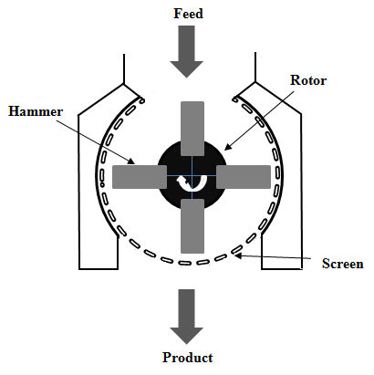
Fig. 1 Schematic diagram of the hammer mill.

1.2. Measuring devices:
Vernier caliper (model DIN 862, measuring range 0- 150 mm with an accuracy of ± 0.05 mm) was used to measure the diameter of different sieve holes, diameter of different die holes and dimensions of corn grains. The power requirement (kW) was determined by recording the voltage and current strength by using the clamp meter (made in China, Model DT266, Measuring range 200/1000A and 750/1000V with an accuracy of ± 0.01) to measure the line current strength (I) and the potential difference value (V). Two digital balances were used during the experiment execution. Balance (1) (made in China, Model YH-T7E, measuring range of 0- 300 kg ± 0.05 kg) It was used to determine the mass of the ground grains before grinding process. Balance (2) (made in Japan, model CG-12K, measuring range of 0-12 kg ± 0.001 kg) It was used to determine the mass of the ground grains after grinding process (samples 200 g). Grain moisture tester (made in Japan, model PM 300 and accuracy ± 0.2- 0.5%) It is used to record moisture content for grains. Standard testing sieve (made in Egypt, No. of sieves 5 and measuring range of 1- 7 mm) used to clear grinding grain for measuring the fineness degree, mean weight diameter and size reduction ratio.
2. Methods:
The hammer mill was evaluated at three sieve holes diameter (4, 6 and 8 mm) and three levels of corn moisture contents (10, 14 and 18% w.b). The mill productivity is determined by dividing the product mass by time; Mg/h.
2.1. The specific energy consumption:
Electrical power consumption was estimated from the measured electric current and voltage values and estimated according to Kurt (l979) as follows from equation:
$Ep=\frac{\sqrt{3}*I*V*η*cosφ}{1000}$ (1)
Where Ep is the electrical power, kW, I the electric current, Amperes, η the mechanical efficiency assumed to be 0.95 (Metwally, 2010), V the electrical voltage, V and cos φ the power factors being equal to (0.84).

The specific energy consumption (kJ/kg) was calculated by using the following equation:
$The specific energy consumption=\frac{Total energy consumption}{Productivity}$ (2)
2.2. Energy density consumption:
The energy density consumption (kJ/m³) was calculated by using the following equation:
$Ed=SEC*ρ$ (3)
$$ρ=\sum_{i=1}^{n}{∅_{i} ρ_{i}}$$
(4)
Where Ed is the energy density, kJ/m³, ρ the bulk density of the ground material, kg/m³ and${ ∅}_{i}$ represents the differential weight fraction, kg/kg.
2.3. Fineness degree (particle size distribution):
The ground corn samples were classified in to five main grades on the basis of modulus of fineness as follow: [(particle size <1 mm), (1< particle size < 2 mm), (2< particle size < 3 mm), (3< particle size < 5 mm) and (5< particle size < 7 mm)]. Each grade was weighed and percentage of each class was calculated.
2.4. Mean weight diameter:
To determine the mean weight diameter, the ground corn samples were classified in to five main grades on the basis of modulus of fineness starting from particle size less than 1 mm to larger than 5 mm. The total weight of samples and the mass of each product categories were weighed using a precise digital scale with an accuracy of 0.001 kg. The percent distribution of each fraction was determined by dividing the fraction's mass with the total mass of the output product according to Velu et al., (2006) from the following equation.
$$MWD=\sum_{i=1}^{n}{∅_{i}d_{i}}$$
(5)
Where MWD is the mean weight diameter, mm and d_{i} the particles passing through the aperture size, mm.
2.5. Size reduction ratio:
The size reduction ratio, which is the ratio of initial to final particle size. The size reduction ratio was estimated according to Perry and Green (1984) as follows from equation:
$S_{R}=\frac{Average size of the corn}{Average size of the product}$ (7)
Where S_{R} is the size reduction, times.
2.6. Grinding ability index:
The grinding ability index was calculated as a ratio of the grinding energy to the surface area of the pulverized material described by Dziki and Laskowski (2000).
$GAI=\frac{SEC*ρ*MWD}{6}$ (8)
Where GAI is the grinding ability index, kJ/m², SEC the specific energy consumption, kJ/kg and ρ the bulk density of the grinding material, kg/m³.
2.7. Grinding index:
The grinding index was calculated on the basis of the size reduction theory described by Sokołowski (1996).
$GI=\frac{SEC}{\frac{1}{\sqrt{MWD}}-\frac{1}{\sqrt{D}}}$ (9)
$D={\left(\frac{1}{\sum_{j}{\frac{G_{j}}{\sqrt{D_{j}}}}}\right)}^{2}$ (10)
Where GI is the grinding index, kJ.mm^{0.5}/kg, G_{j} the mass fraction of a particular size class j, kg/kg, D_{j} represents the size of the fraction, mm and D the average particle size of the material before grinding, mm.
2.8. Grinding effectiveness:
The grinding effectiveness, which is the ratio of final to initial surface area. The grinding effectiveness was estimated according to Balasubramanian et al. (2011) as follows:
$Grinding effectiveness=\frac{Surface area after grinding}{Surface area before grinding}$ (11)
The surface area after grinding was calculated according to Balasubramanian et al. (2011) as follows:
$Surface area after grinding=4π{\left(\frac{MWD}{2}\right)}^{2}N$ (12)
$Number of particles \left(N\right)=\frac{Weight of single grain}{Weight of single particle}$ (13)
$Weight of single particle=\frac{4}{3}π {\left(\frac{MWD}{2}\right)}^{3}ρ$ (14)
The surface area before grinding was calculated according to Jain and Bal (1997) as follows:
$Surface area before grinding=\frac{πBL^{2}}{(2L-B)}$ (15)
$B=\sqrt{WT}$ (16)
Where L is the length of single grain, mm, W the width of single grain, mm and T the thickness of single grain, mm.
RESULTS AND DISCUSSIONS
1. Hammer Mill Evaluation:
The mill was evaluated by studying the relationship between the mill performance, energy consumption, grinding index, grinding ability index and ground product quality (mean weight diameter, fineness degree, size reduction, bulk density and grinding effectiveness).
1.1. Performance, specific energy and energy density consumption:
figs 2, 3 and 4 show the effect of sieve hole diameter and cereal moisture content on the performance, the specific energy and energy density consumption of the hammer mill. It could be seen that the mill performance decreased with increasing the moisture content and increased by increasing sieve hole diameter, where it decreased from 1.44 to 0.70 Mg/h at 4 mm hole diameter, from 3.02 to 1.61 Mg/h at 6 mm hole diameter and it decreased from 6.83 to 4.38 Mg/h at 8 mm sieve hole diameter when the moisture increased from 10 to 18%. The reduction percentage was 51.40% at 4 mm hole diameter, 46.70% at 6 mm and 35.90% at 8 mm hole diameter. Meanwhile the increasing percentage due to the effect of sieve hole diameter was 78.92% at 10% moisture content, 80.47% at 14% moisture content and 84.02% at 18% moisture content.
These results could be attributed to that the increase of grain moisture content caused an increase of grain plasticity and thus difficulties with grinding therefore needs more time to complete grinding, which leads to lower productivity of the hammer mill (Dziki and Laskowski, 2005).
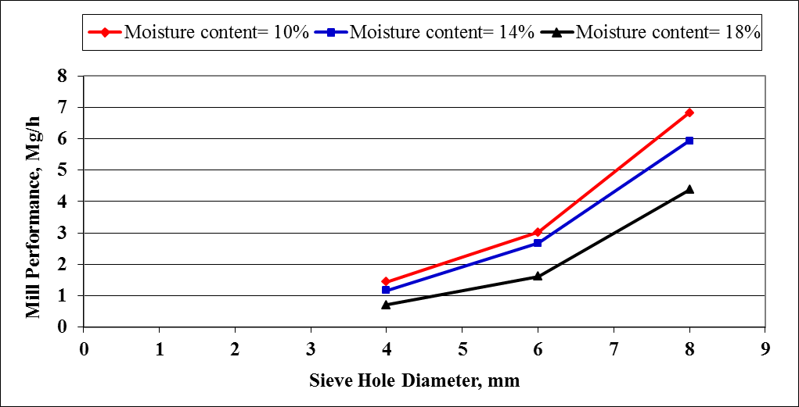
Figure 2 Effect of moisture content and sieve holes diameter on mill performance.
Multiple regression was carried out to find a relationship between the mill performance and both the moisture content (10- 18%) and sieve hole diameter (4- 8 mm). the most suitable form obtained was as follows:
Mp = 1.39 (Ds) – 0.20 (Mc) – 0.94 (R²) = 0.92 (1)
Where Mp is the mill performance, Mg/h, Ds sieve hole diameter, mm and Mc moisture content, %.

Regarding the specific energy consumption, the results indicated that the specific energy consumption increased with increasing the moisture content and decreased with increasing the sieve hole diameter, where it increased from 15.83 to 32.72 kJ/kg at 4 mm hole diameter, from 7.57 to 14.24 kJ/kg at 6 mm hole diameter and it increased from 3.38 to 5.20 kJ/kg at 8 mm sieve hole diameter when the moisture increased from 10 to 18%. The increasing percentage was 51.62% at 4 mm hole diameter, 46.84 % at 6 mm and 35.00% at 8 mm hole diameter. Meanwhile the reduction percentage due to the effect of sieve hole diameter was 78.65% at 10% moisture content, 80.47% at 14% moisture content and 84.11% at 18% moisture content.
This may be due to the fact that the increase in moisture content causes increase in kernel plasticity therefore increases the shear strength of the corn grain, which leads to higher energy consumption for grinding (Glenn and Johnston, 1992; Mabille et al., 2001 and Annoussamy et al., 2000). These results trend agreed with those obtained by Dziki and Laskowski, (2005) and Hassan, (1994).
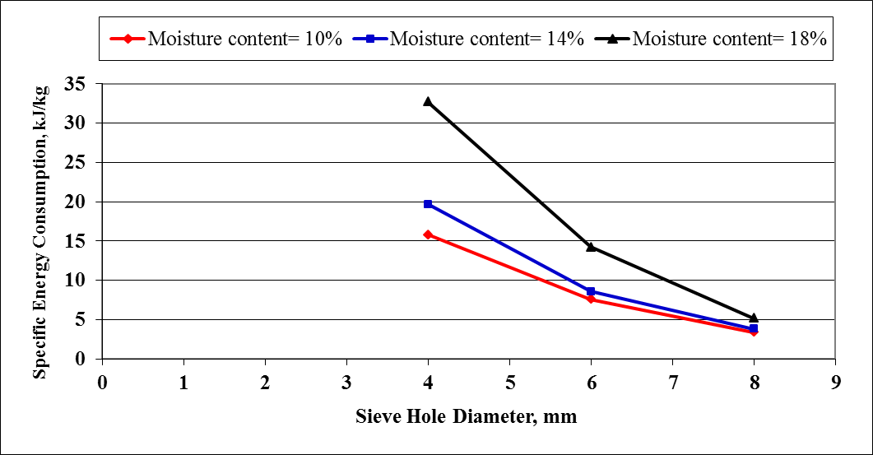
Figure 3 Effect of moisture content and sieve holes diameter on specific energy consumption of corn grinding.

Multiple regression was carried out to find a relationship between the specific energy consumption and both the moisture content (10- 18%) and sieve hole diameter (4- 8 mm). the most suitable form obtained was as follows:
SEC = -4.89 (Ds) + 0.94 (Mc) + 28.81 (R²) = 0.87 (2)
Where SEC is the specific energy consumption, kJ/kg,

Regarding the energy density consumption, the results indicated that the energy density consumption increased with increasing the moisture content and decreased with increasing the sieve hole diameter, where it increased from 9.84 to 18.82 MJ/m³ at 4 mm hole diameter, from 4.56 to 7.61 MJ/m³ at 6 mm hole diameter and it increased from 1.99 to 2.73 MJ/m³ at 8 mm sieve hole diameter when the moisture increased from 10 to 18%. The increasing percentage was 47.72% at 4 mm hole diameter, 40.08% at 6 mm and 27.12% at 8 mm hole diameter. Meanwhile the reduction percentage due to the effect of sieve hole diameter was 79.78% at 10% moisture content, 81.57% at 14% moisture content and 85.49% at 18% moisture content.
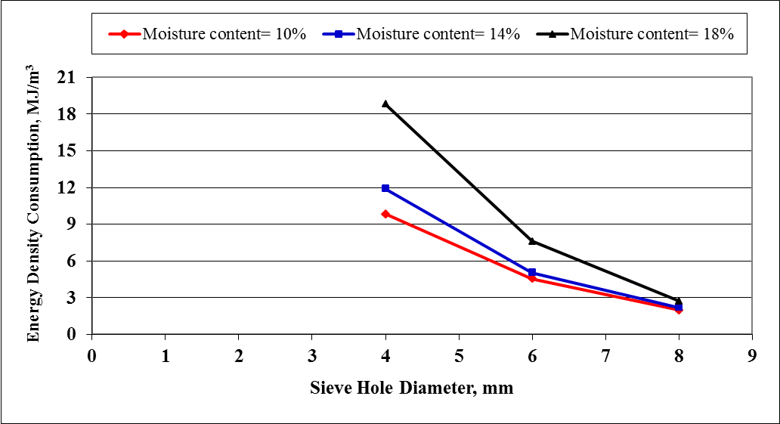
Figure 4 Effect of moisture content and sieve holes diameter on energy density consumption.
1.2. Grinding index and grinding ability index:
figs 5 and 6 show the effect of sieve hole diameter and cereal moisture content on the grinding index and the grinding ability index of the hammer mill. It could be seen that the grinding index increased with increasing the moisture content and decreased with increasing sieve hole diameter, where it increased from 34.44 to 91.28 kJ mm^{0.5}/kg at 4 mm hole diameter, from 20.02 to 45.17 kJ mm^{0.5}/kg at 6 mm hole diameter and it increased from 12.35 to 23.31 kJ mm^{0.5}/kg at 8 mm sieve hole diameter when the moisture increased from 10 to 18%. The increasing percentage was 62.27% at 4 mm hole diameter, 55.68% at 6 mm and 47.02% at 8 mm hole diameter. Meanwhile the reduction percentage due to the effect of sieve hole diameter was 64.14% at 10% moisture content, 68.51% at 14% moisture content and 74.46% at 18% moisture content.
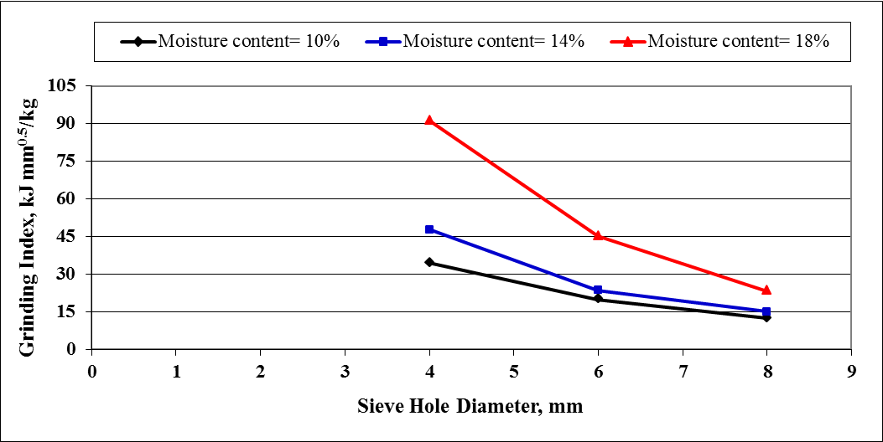
Figure 5 Effect of moisture content and sieve holes diameter on grinding index.

Multiple regression was carried out to find a relationship between the grinding index and both the moisture content (10- 18%) and sieve hole diameter (4- 8 mm). the most suitable form obtained was as follows:
GI = -11.03 (Ds) + 3.47 (Mc) + 53.41 (R²) = 0.83 (3)
Where GI is the grinding index, kJ. mm ^{0.5}/kg.

The grinding ability index is an important indicator for the relationship between the required energy of grinding and the level of pulverization of ground cereal the results indicated that it ranged from 0.81 to 6.00 kJ/m² depending on the sieve hole diameter and the moisture content of the cereals. The results indicated that the grinding ability index increased with increasing the moisture content and decreased with increasing the sieve hole diameter, where it increased from 2.41 to 6.00 kJ/m² at 4 mm hole diameter, from 1.38 to 2.74 kJ/m² at 6 mm hole diameter and it increased from 0.81 to 1.31 kJ/m² at 8 mm sieve hole diameter when the moisture increased from 10 to 18%. The increasing percentage was 59.83% at 4 mm hole diameter, 49.64 % at 6 mm and 38.17% at 8 mm hole diameter. Meanwhile the reduction percentage due to the effect of sieve hole diameter was 66.39% at 10% moisture content, 71.12% at 14% moisture content and 78.17% at 18% moisture content. The results are similar to these reported by Dziki and Laskowski (2010).
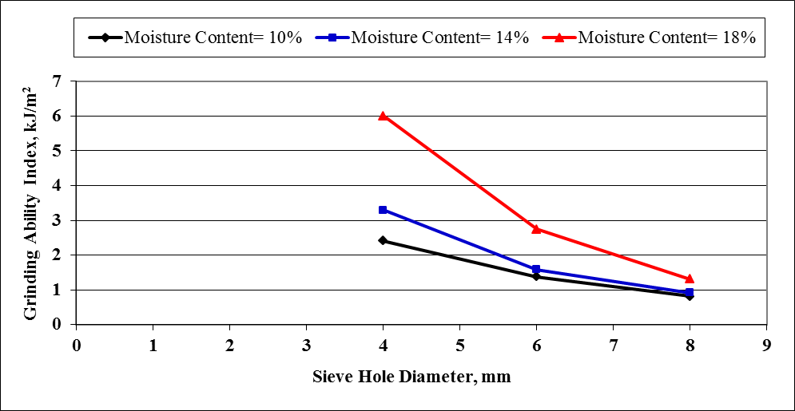
Figure 6 Effect of moisture content and sieve holes diameter on grinding ability index.

Multiple regression was carried out to find a relationship between the grinding ability index and both the moisture content (10- 18%) and sieve hole diameter (4- 8 mm). the most suitable form obtained was as follows:
GAI = -0.78 (Ds) + 0.20 (Mc) + 4.26 (R²) = 0.83 (4)
Where GAI is the grinding ability index, kJ/m².
1.3. The ground quality:
1.3.1. Product mean weight diameter and size reduction:
figs 7 and 8 show the effect of sieve hole diameter and cereal moisture content on the product mean weight diameter and size reduction of the hammer mill. It could be seen that the product mean weight diameter increased with increasing the moisture content and increased by increasing sieve hole diameter where it increased from 1.47 to 1.91 mm at 4 mm hole diameter, from 1.81 to 2.16 mm at 6 mm hole diameter and it increased from 2.45 to 2.89 at 8 mm sieve hole diameter when the moisture increased from 10 to 18%. The increasing percentage was 23.04% at 4 mm hole diameter, 16.20% at 6 mm and 15.22% at 8 mm hole diameter. Meanwhile the increasing percentage due to the effect of sieve hole diameter was 40.00% at 10% moisture content, 36.15% at 14% moisture content and 33.91% at 18% moisture content.
Multiple regression was carried out to find a relationship between the product weight mean diameter and both the moisture content (10- 18%) and sieve hole diameter (4- 8 mm) using sieve the most suitable form obtained was as follows:
MWD = 0.25 (Ds) + 0.06 (Mc) – 0.22 (R²) = 0.93 (5)
Where MWD is the product mean weight diameter, mm.
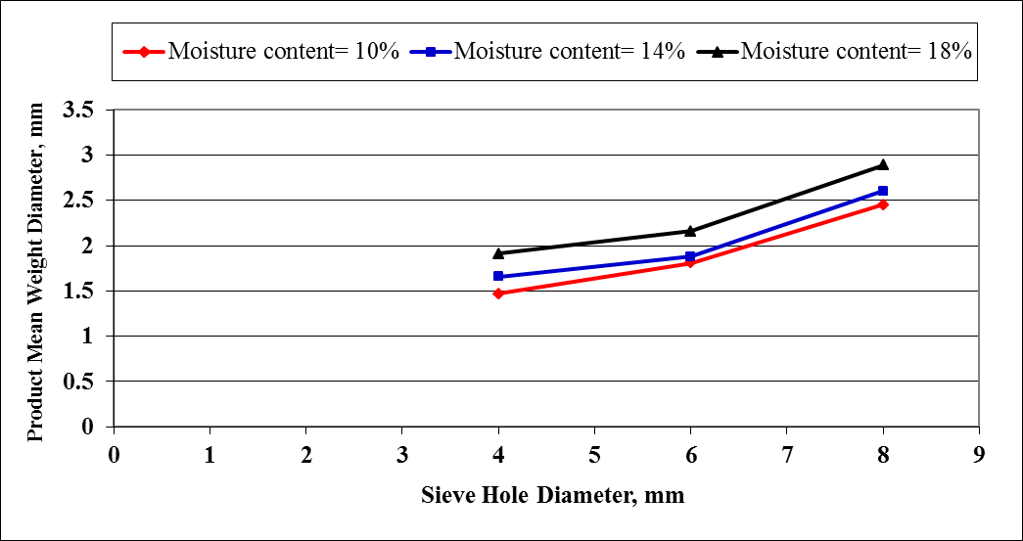
Figure 7 Effect of moisture content and sieve holes diameter on product mean weight diameter.

Regarding the size reduction, the results indicated that the size reduction decreased with increasing both the moisture content and sieve hole diameter, where it decreased from 5.10 to 3.93 times at 4 mm hole diameter, from 4.14 to 3.47 times at 6 mm hole diameter and it decreased from 3.11 to 2.70 times at 8 mm sieve hole diameter when the moisture increased from 10 to 18%. The reduction ratio percentage was 22.94% at 4 mm hole diameter, 16.18% at 6 mm and 13.18% at 8 mm hole diameter. Meanwhile the reduction percentage due to the effect of sieve hole diameter was 39.02% at 10% moisture content, 32.08% at 14% moisture content and 31 % at 18% moisture content.
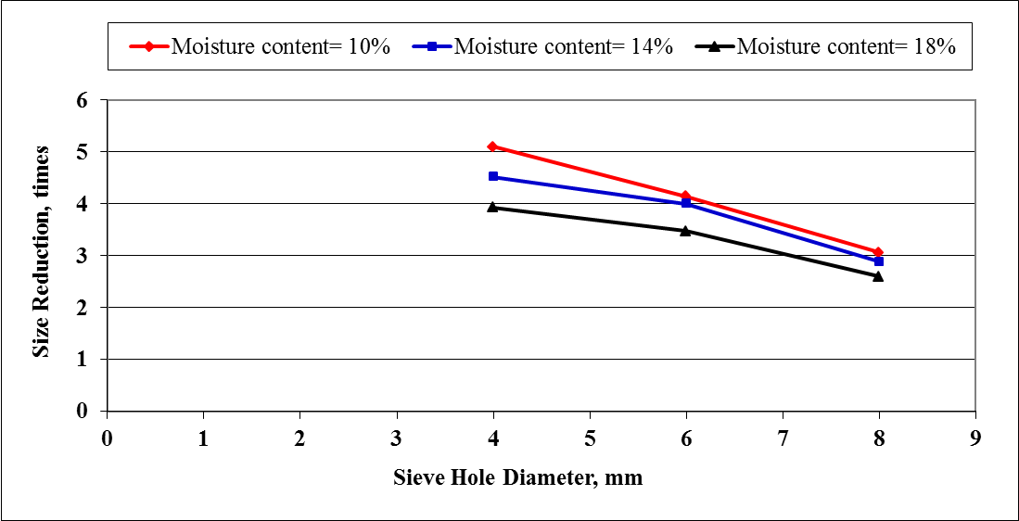
Figure 8 Effect of moisture content and sieve holes diameter on size reduction.

Multiple regression was carried out to find a relationship between the size reduction and both the moisture content (10- 18%) and sieve hole diameter (4- 8 mm). The most suitable form obtained was as follows:
S_{R} = - 0.40 (Ds) – 0.09 (Mc) + 7.30 (R²) = 0.94 (6)
Where S_{R} is the size reduction, times.
From the results, it could be concluded that the mean weight diameter ranged from 1.47 to 2.89 mm as the sieve hole diameter changed from 4 to 8 mm. on the other hand, the size reduction reached as high 5.10 times to as low as 2.60 as the sieve hole diameter changed from 4 to 8 m with different moisture content (10- 18%).
1.3.2. Fineness degree (Particle size distribution):
fig 9 shows the effect of sieve hole diameter and cereal moisture content on the fineness degree. It could be seen that the increase of grains moisture content caused a decrease in percentage of fine milled corn (FMC), while percentage of coarse milled corn (CMC) increases. The obtained results show that, decrease percentage of (FMC) from 38.34 to 30.34% at 4 mm hole diameter, from 32.82 to 28.17% at 6 mm hole diameter and it decreased from 25.50 to 17.50% at 8 mm hole diameter, while the percentage of (CMC) increase from 5.50 to 19.33% at 4 mm hole diameter, from 16.33 to 28.67% at 6 mm hole diameter and it increased from 37.17 to 48.17% at 8 mm hole diameter. Also it noticed that the increase of sieve hole diameter caused a decrease in percentage of (FMC), while percentage of coarse milled corn (CMC) increases.
Therefore, it can be concluded that the percentage of fin grinding is inversely proportional with the sieve hole diameter and grain moisture content. This can be explained by the fact that the resistance force decreases when the hole diameter increases and material can easily pass through the sieve hole diameter without much friction. These results trend agreed with those obtained by Abdel Mottaleb et al. (2009).
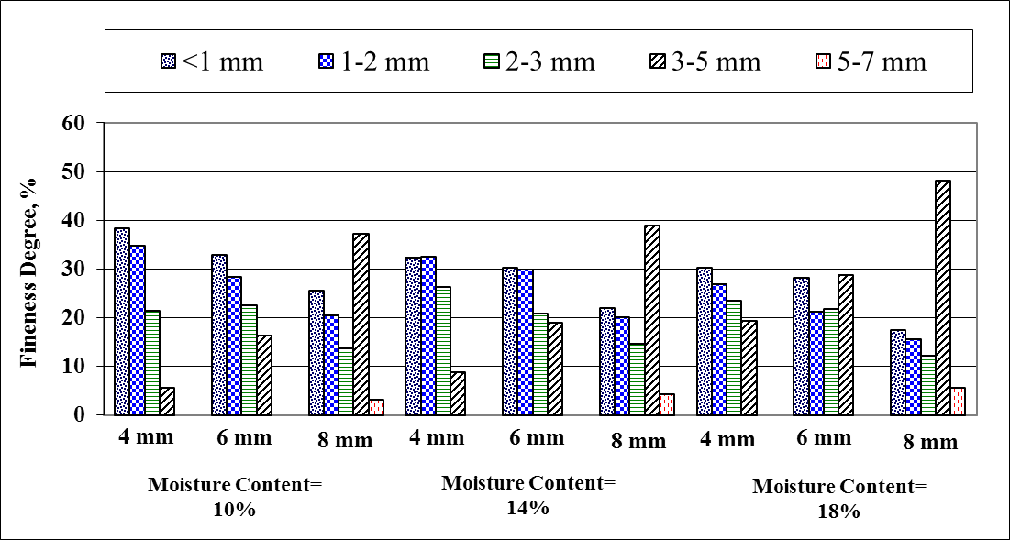
Figure 9 shows the effect of sieve hole diameter and cereal moisture content on the fineness degree.
1.3.3. Bulk density:
fig 10 shows the effect of sieve hole diameter and cereal moisture content on the bulk density of corn crushed. It could be seen that the bulk density decreased with increasing the moisture content and decreased by increasing sieve hole diameter, where it decreased from 621.34 to 575.08 kg/m³ at 4 mm hole diameter, from 602.17 to 534.28 kg/m³ at 6 mm hole diameter and it decreased from 590.20 to 524.58 kg/m³ at 8 mm sieve hole diameter when the moisture increased from 10 to 18%. The reduction percentage was 7.45% at 4 mm hole diameter, 11.27% at 6 mm and 11.12% at 8 mm hole diameter. Meanwhile the reduction percentage due to the effect of sieve hole diameter was 5.01% at 10% moisture content, 5.60% at 14% moisture content and 8.78% at 18% moisture content.
This was due to the fact that an increase in mass owing to moisture gain in the sample was lower than accompanying volumetric expansion of the bulk (Pradhan et al., 2008).
Multiple regression was carried out to find a relationship between the bulk density and both the moisture content (10- 18%) and sieve hole diameter (4- 8 mm). the most suitable form obtained was as follows:
ρ = -9.62 (Ds) – 7.49 (Mc) + 741.44 (R²) = 0.93 (7)
Where ρ is the bulk density, kg/m³.
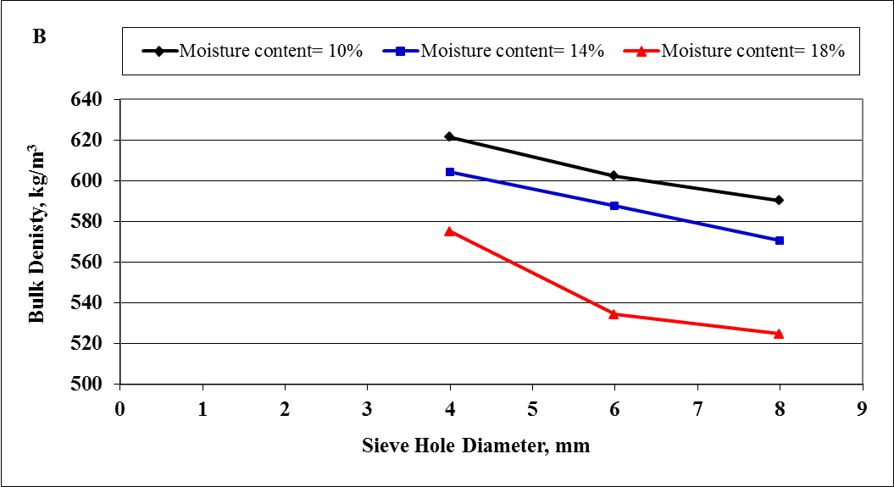
Figure 10 Effect of moisture content and sieve holes diameter on bulk density of corn crushed.
1.3.4. Grinding effectiveness:
Table 2 shows the effect of sieve hole diameter and cereal moisture content on the grinding effectiveness of the hammer mill. It could be seen that the grinding effectiveness decreased with increasing the sieve hole diameter, where it decreased from 14.40 to 8.88 at 10% moisture content, from 13.74 to 9.08 at 14% moisture content and it decreased from 13.47 to 9.82 at 18% moisture content when the sieve hole diameter increased from 4 to 8 mm. The reduction percentage was 38.33% at 10% moisture content, 33.92% at 14% and 27.10% at 18% moisture content.

Table 7 Effect of sieve hole diameter and cereal moisture content on the grinding effectiveness.
Sieve holes diameter, mm | Moisture content, % | Surface area before grinding, mm² | WSG, g | WSP, g | MWD, mm | Number of particles (N) | Surface area after grinding, mm² | Grinding effectiveness
4 | 10 | 127.26 | 0.27 | 0.0010 | 1.47 | 270.00 | 1832.01 | 14.40
 | 14 | 134.92 | 0.30 | 0.0014 | 1.66 | 214.29 | 1854.16 | 13.74
 | 18 | 145.74 | 0.36 | 0.0021 | 1.91 | 171.43 | 1963.74 | 13.47
6 | 10 | 127.26 | 0.27 | 0.0018 | 1.81 | 150.00 | 1543.04 | 12.12
 | 14 | 134.92 | 0.30 | 0.0021 | 1.88 | 142.86 | 1585.46 | 11.75
 | 18 | 145.74 | 0.36 | 0.0028 | 2.16 | 128.57 | 1883.55 | 12.92
8 | 10 | 127.26 | 0.27 | 0.0045 | 2.45 | 60.00 | 1130.87 | 8.88
 | 14 | 134.92 | 0.30 | 0.0052 | 2.60 | 57.70 | 1224.76 | 9.08
 | 18 | 145.74 | 0.36 | 0.0066 | 2.89 | 54.55 | 1430.61 | 9.82
WSG: weight of single grain and WSP: weight of single particle.

Multiple regression was carried out to find a relationship between the grinding effectiveness and both the moisture content (10- 18%) and sieve hole diameter (4- 8 mm). the most suitable form obtained was as follows:
GE = -1.15 (Ds) + 0.03 (Mc) + 18.24 (R²) = 0.93 (8)
Where GE is the grinding effectiveness.

CONCLUSION
- The highest performance (6.83 Mg/h) was obtained at 8 mm hole diameter and 10% moisture content which decreased to the lowest performance (0.7 Mg/h) which obtained at 4 mm hole diameter and 18% moisture content.
- The highest specific energy, energy density consumption, grinding index and grinding ability index 32.72 kJ/kg, 18.82 MJ/m³, 91.28 kJ.mm^{0.5}/kg and 6.00 kJ/m², respectively were obtained at 4 mm hole diameter and 18% moisture content which decreased to the lowest specific energy and energy density consumption, grinding index and grinding ability index 3.38 kJ/kg, 1.99 MJ/m³, 12.35 kJ.mm^{0.5}/kg and 0.81 kJ/m², respectively at 8 mm hole diameter and 10% moisture content.
- The ground product:
- The highest mean weight diameter (2.89 mm) was obtained at 8 mm hole diameter and 18% moisture content which decreased to the lowest mean weight diameter (1.47 mm) which obtained at 4 mm hole diameter and 10% moisture content.
- The highest size reduction and bulk density 5.10 times and 621.34 kg/m³, respectively was obtained at 4 mm hole diameter and 10% moisture content which decreased to the lowest size reduction and bulk density 2.60 times and 524.58 kg/m³, respectively which obtained at 8 mm hole diameter and 18% moisture content.
- The highest grinding effectiveness (14.40) was obtained at 4 mm hole diameter and 10% moisture content which decreased to the lowest grinding effectiveness (8.88) which obtained at 8 mm hole diameter and 10% moisture content.

REFERENCES
Abdel Mottaleb, A. F., W. A. EL Dahshan and L. Bejo. 2009. Optimization of milling farm residues using a local hammer mill. Farm Machinery and Power of Misr J. Ag. Eng., 26(3): 1172 – 1189.
Balasubramanian, S., R. Sharma and S. R. Vijay Kumar. 2011. Effect of moisture content and feed rate on size reduction of pearl millet. Journal of Food Science and Engineering, 1: 93- 99.
Dziki, D. 2008. The crushing of wheat kernels and its consequence on the grinding process. Powder Technology, 185: 181– 186.
Dziki, D. and J. Laskowski 2005. Influence of selected factors on wheat grinding energy requirements. TEKA Kom. Mot. Energ. Roln., 5, 56- 64.
Dziki, D. and J. Laskowski. 2000. Badanie właściwości przemiałowych wybranych odmian pszenicy. InŜynieria Rolnicza., 8 (19), 63-69.
Dziki, D. and J. Laskowski. 2006. Influence of wheat grain mechanical properties on grinding energy requirements. TEKA Kom. Mot. Energ. Roln., 6A, 45– 52.
Dziki, D. and J. Laskowski. 2010. Study to analyze the influence of sprouting of the wheat grain on the grinding process. Journal of Food Engineering, 96: 562– 567.
Egela, M. I., Y. F. Sharobeem and M. E. Badawy. 2003. Modification of some operational parameters for local manufactured hammer mill. The 11th annual conference of Misr Society of Ag. Eng., 15-16 Oct. 2003: 830- 840.
Fang, Q. 1995. Effects of physical properties of wheat and operational parameters of roller mills on size reduction. MS thesis, Kansas State Univ., Manhattan, Kansas.
Gehle, H. 1965. The MIAG “Vario” Rollstand: Design and purpose. Amer. Assoc. of Operative Millers’ Tech. Bull. (May): 2861– 2862.
Glenn, G.M. and R. K. Johnston. 1992. Moisture-dependent changes in the mechanical properties of isolated wheat. J. Cereal Sci., 15: 223– 236.
Hassan, M. A. 1994. Modifying and evaluation a small locally made mix-milling unit suitable for Egyptian poultry farms. Misr J. Ag. Eng., 11(2):569 -584.
Jain, R. K., and S. Bal. 1997. Properties of pearl millet. Journal of Agricultural Engineering Research, 66: 85–91.
Kilborn, R. H., H. C. Black, J. E. Dexter and D. G. Martin. 1982. Energy consumption during flour milling. Description of two measuring systems and influence of wheat hardness on the energy requirements. Cereal Chemistry, 59: 284–288.
Kurt, G. l979. Engineering formulas. 3rd. Ed. McGraw – Hill book Co.
Mabille, F., J. Gril and J. Abecassis. 2001. Mechanical properties of wheat seed coat. Cereal Chem., 78: 231– 235.
Mani, S., L. G. Tabil, and S. Sokhansanj. 2004. Grinding performance and physical properties of wheat and barley straws, corn stover and switchgrass. Biomass Bioenergy, 27: 339- 352.
Metwally, K. A. 2010. Study the effect of some operational Factors on hammer mill. A MSC thesis of Department of Agricultural Engineering, Faculty of Agriculture, Zagazig University. Egypt.
Perry, R. H. and D. Green. 1984. Perryʹs chemical engineersʹ handbook (5th ed). New York: McGraw-Hill Book Company.
Pradhan, R. C., S. N. Naik, N. Bhatnagar, and S. K. Swain. 2008. Moisture-dependent physical properties of Karanja (Pongamia pinnata) kernel. Industrial Crops and Products, 28(2): 155-161.
Pujol, R., C. Letang, I. Lempereur, M. Chaurand, F. Mabille and J. Abecassis. 2000. Description of a micro mill with instrumentation for measuring grinding characteristics of wheat grain. Cereal Chem., 77(4): 421– 427.
Sokołowski, M. 1996. Energy consumed in grinding– a new idea of a general law of comminution– new tests stands and testing results. Recents Progress en Genie Procedes, 10: 221–226.
Velu, V., A. Nagender, P. G. Prabhakara Rao and D. G. Rao. 2006. Dry milling characteristic of microwave dried maize grains. Journal of Food Engineering 74, 30– 36.
Vigneault, C., T. M. Rothwell and G. B. Bourgeois. 1992. Hammer mill grinding rate and energy requirements for thin and conventional hammers. Canadian Agricultural Engineering, 34(2): 203-207.

عوامل الجرش وتأثيرها على جودة الذرة لتصنيع العلف
مختار دبور، عادل بهنساوى، سمير احمد على2، زكريا الحداد
قسم الهندسة الزراعية- كلية الزراعة- جامعة بنها

اجريت هذه الدراسة لدراسة عوامل الجرش وتأثيرها على جودة الذرة المجروش اللازم لتصنيع العلف. تم تقييم المجرشة المطرقية عند اختلاف اقطار فتحات الغربال وكذلك المحتوى الرطوبى للحبوب لدراسة مؤشرات الجرش انتاجية المجرشة، استهلاك الطاقة النوعى، كثافة الطاقة المستهلكة، معامل الجرش، معامل قابلية الجرش وكذلك جودة المنتج المجروش بها تحت ظروف التشغيل المختلفة. وقد اظهرت نتائج تقييم المجرشة ان معدل اداء المجرشة، استهلاك الطاقة النوعى، كثافة الطاقة المستهلكة، معامل الجرش ومعامل قابلية الجرش تراوح بين 0,70- 6,83 ميجاجم/ساعة، 3,38- 32,72 كجول/كجم، 1,99- 18,82 ميجاجول/م³ ، 12,35- 91,28 كجول.مم^{0,5}/كجم و 0,81- 6,00 كجول/م² على التوالى. تراوحت قيم كلاً من متوسط القطر الوزنى، نسبة التخفيض ، الكثافة الظاهرية وفاعلية الجرش بين 1,47- 2,89 مم، 2,60- 5,10 مره، 524,58- 621,34 كجم/م³ و 8,88- 14,40على التوالى عند اختلاف قطر فتحات الغربال وكذلك المحتوى الرطوبى للحبوب.
الكلمات الدالة: الجرش، استهلاك الطاقة النوعى، معدل الاداء، درجة النعومة، نسبة التخفيض.

معيد بقسم الهندسة الزراعية – كلية الزراعة - جامعـة بنهــا.
استاذ الهندســة الزراعيـــة - كلية الزراعــة - جامعـــــة بنهـا.
استاذ الهندسة الزراعية المتفرغ – كلية الزراعة - جامعة بنها.

